**Heap**

Table of Contents

**Heap Concepts** 2

What is heap? 2

Heap implementation in python 3

Custom Heap Implementation 4

LEVEL 1: **EASY** 5

1. Kth Largest Element in an Array 5

2. Kth Largest Element in a stream 5

3. Final Array State After K Multiplication Operations I 5

4. Sort Array by Increasing Frequency 5

5. Minimum Amount of time to Fill Cups 5

6. Find Subsequence of Length K with Largest Sum 5

**LEVEL** 2: **Medium** 6

7. Array Removal 6

LEVEL 3: **Difficult** 7

**SOLUTIONS:** 8

**LEVEL 1:** 8

**LEVEL 2:** 11

# **Heap Concepts**

## What is heap?

A **Heap** is a specialized **complete binary tree** that satisfies the **heap property**:

* **Max Heap**: Parent is **greater than or equal** to its children.
* **Min Heap**: Parent is **less than or equal** to its children.

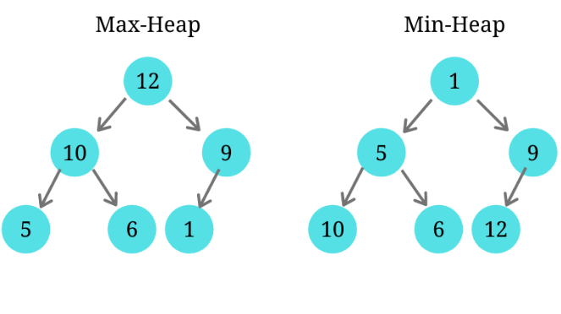

**Key Properties:**

1. **Complete Binary Tree**: All levels are filled except maybe the last, which is filled left to right.
2. Usually implemented as **array** (index-based binary tree).
3. Commonly used in:

* Priority Queues
* Heap Sort
* Dijkstra’s Algorithm
* Median finding
* Scheduling Systems

**Heap can be expressed as array:**

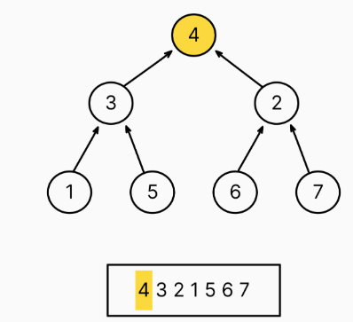

For node at index i:

* Left child: 2*i + 1
* Right child: 2*i + 2
* Parent: (i - 1) // 2

## Heap implementation in python

Python uses **Min Heap** by default. For max heap make values negative.

import heapq

#min heap working

heap = []

heapq.heappush(heap, 5)

heapq.heappush(heap, 1)

heapq.heappush(heap, 3)

print(heapq.heappop(heap))  # 1 (min element)

#max heap, implement by making values negative

heap = []

heapq.heappush(heap, -5)

heapq.heappush(heap, -1)

heapq.heappush(heap, -3)

print(-heapq.heappop(heap))  # 5 (max element)

Heap push and pop can be imagined as stack, for min heap top value at stack is minimum. Pop from min heap gives min value

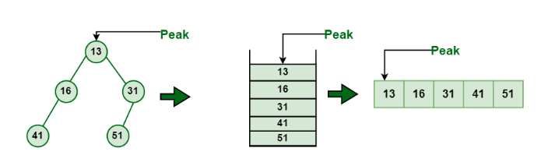

**Time Complexities:**

1. Insert : O(logn)
2. Get Min/Max: O(1)
3. Delete Min/Max : O(logn)
4. Heapify: O(logn)

* **Insertion**(heapify-up): Add at the end, swap with parent if violating the property
* **Deletion**(heapify-down): Remove root, replace with last element, restore heap property

**When to use heap:**

1. If asked kth largest: use min heap (of size k, if heap size exceeds k, pop the smallest)
2. If asked kth smallest: use max heap

Can use sorting too in above cases, but sorting is O(nlogn). Whereas using heap it will be O(nlogk).

## Custom Heap Implementation

class MinHeap:

    def __init__(self):

        self.heap = []

    def insert(self, val):

        self.heap.append(val)

        self._heapify_up(len(self.heap) - 1)

    def pop(self):

        if len(self.heap) == 0:

            return None

        val = self.heap[0]

        self.heap[0] = self.heap.pop()

        self._heapify_down(0)

        return val

    def _heapify_up(self, i):

        parent = (i - 1) // 2

        if i > 0 and self.heap[i] < self.heap[parent]:

            self.heap[i], self.heap[parent] = self.heap[parent], self.heap[i]

            self._heapify_up(parent)

    def _heapify_down(self, i):

        smallest = i

        left = 2 * i + 1

        right = 2 * i + 2

        if left < len(self.heap) and self.heap[left] < self.heap[smallest]:

            smallest = left

        if right < len(self.heap) and self.heap[right] < self.heap[smallest]:

            smallest = right

        if smallest != i:

            self.heap[i], self.heap[smallest] = self.heap[smallest], self.heap[i]

            self._heapify_down(smallest)

**Heap Sort**

def heap_sort(arr):

    heapq.heapify(arr)  # In-place min-heap

    return [heapq.heappop(arr) for _ in range(len(arr))]

print(heap_sort([4, 1, 3, 2, 16, 9]))  # [1, 2, 3, 4, 9, 16]

# LEVEL 1: **EASY**

### Kth Largest Element in an Array

Link: <https://leetcode.com/problems/kth-largest-element-in-an-array/>

### Kth Largest Element in a stream

Link: <https://leetcode.com/problems/kth-largest-element-in-a-stream/>

### Final Array State After K Multiplication Operations I

Link: <https://leetcode.com/problems/final-array-state-after-k-multiplication-operations-i/>

### Sort Array by Increasing Frequency

Link: <https://leetcode.com/problems/sort-array-by-increasing-frequency/>

### Minimum Amount of time to Fill Cups

Link: <https://leetcode.com/problems/minimum-amount-of-time-to-fill-cups/>

### Find Subsequence of Length K with Largest Sum

Link: <https://leetcode.com/problems/find-subsequence-of-length-k-with-the-largest-sum/>

# **LEVEL** 2: **Medium**

### Minimum cost of ropes

Link: <https://www.geeksforgeeks.org/problems/minimum-cost-of-ropes-1587115620/1>

# LEVEL 3: **Difficult**

# **SOLUTIONS:**

## **LEVEL 1:**

1. **Kth largest Element in an Array**

import heapq

class Solution:

    def findKthLargest(self, nums: List[int], k: int) -> int:

        # for kth largest, use min heap

        heap = []

        for num in nums:

            heapq.heappush(heap,num)

            if len(heap)>k:

                heapq.heappop(heap)

        # Can also do heap[0]

        return heapq.heappop(heap)

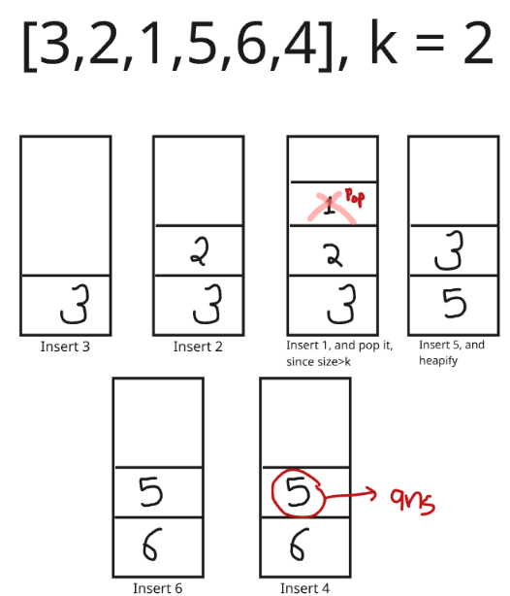

**2. Kth Largest Element in a Stream**

class KthLargest(object):

    def __init__(self, k, nums):

        self.k = k

        self.nums = nums

        heapq.heapify(self.nums)  # Convert nums into a heap

        # If the heap is larger than k, remove the smallest elements until it has exactly k elements

        while len(self.nums) > k:

            heapq.heappop(self.nums)

    def add(self, val):

        heapq.heappush(self.nums, val)

        # If after adding the new value, the heap has more than k elements, pop the smallest

        if len(self.nums) > self.k:

            heapq.heappop(self.nums)

        # The smallest element in the heap is now the k-th largest element

        return self.nums[0]

**3. Final Array State After K Multiplication Operations |**

import heapq

class Solution:

    def getFinalState(self, nums: List[int], k: int, multiplier: int) -> List[int]:

        mh = [[nums[i],i] for i in range(len(nums))]

        #if pair is passed to heapify, it executes logic considering first value from pair

        heapq.heapify(mh)     #can directly convert array to heap using heapify

        for _ in range(k):

            v,ind = heapq.heappop(mh)

            v = v*multiplier

            nums[ind] = v

            heapq.heappush(mh, [v,ind])

        return nums

**4. Sort Array by Increasing Frequency**

If in heap we push 2 values [x,y] , if x is same for 2 values, y is considered for sorting.

class Solution:

    def frequencySort(self, nums: List[int]) -> List[int]:

        c = Counter(nums)

        heap = []

        # min heap based on frequecy

        # if freq is same, larger value should come first

        for k,v in c.items():

            heapq.heappush(heap,[v,-k])

        ans=[]

        while heap:

            freq,key = heapq.heappop(heap)

            ans += [-key]*freq

        return ans

**5. Minimum Amount of Time to Fill Cups**

class Solution:

    def fillCups(self, amount: List[int]) -> int:

        heap = []

        #since need to remove max 2, use max heap

        for i in amount:

            if i != 0:  #if 0 present in amount, remove them

                heapq.heappush(heap, -i)

        steps = 0

        while heap:

            if len(heap) >= 2:

                x1 = heapq.heappop(heap)

                x2 = heapq.heappop(heap)

                x1 += 1   #since values are negative, add 1(inplace of -1)

                x2 += 1

                if x1 != 0:

                    heapq.heappush(heap, x1)

                if x2 != 0:

                    heapq.heappush(heap, x2)

                steps += 1

            else:

                x1 = -heapq.heappop(heap)

                steps += x1

        return steps

**6 . Find Subsequence of Length K With the Largest Sum**

**Approach:**

1. **Pair each element with its index** → [value, index].
2. **Sort in descending order** of values.
3. **Select the top** k **elements** (largest values).
4. **Sort these** k **elements by their original indices** to maintain order.
5. **Extract the values** to form the result.

import heapq

class Solution:

    def maxSubsequence(self, nums: List[int], k: int) -> List[int]:

        heap=[]

        #using max heap, will fetch top k  elements from heap

        for i in range(len(nums)):

            heapq.heappush(heap,[-nums[i],i])

        #don't take top k like this, you have to pop it

        # a = heap[:k] (wrong way)

        a = [heapq.heappop(heap) for _ in range(k)]

        a.sort(key=lambda x:x[1])

        return [-val[0] for val in a]

## **LEVEL 2:**

1. Minimum Cost of Ropes

#Approach, on joining top 2 minimum length ropes, we can get min cost

# 4,3,2,6  Join 2,3  =>   [4,5,6] cost=5

#          Join 4,5  =>   [9,6]  cost=5+9

#          Join 9,6  =>   [15]  cost= 5+9+15 = 29

#Try other approach, only this gives best answer

import heapq

class Solution:

    def minCost(self, arr):

        heapq.heapify(arr)

        cost=0

        while(len(arr)!=1):

            x = heapq.heappop(arr)

            y = heapq.heappop(arr)

            cost += (x+y)

            heapq.heappush(arr,(x+y))

        return cost